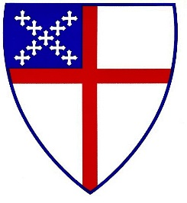

Christianity 101-Fall 2016

Wednesday evenings

Oct. 5, 12, 19 and Nov. 2, 9, and 16.
5.30 p.m. Holy Eucharist II with Healing Prayers
6:15 p.m. -7:30 p.m. Dinner and discussion
What are the fundamental things Christians believe? Who is Jesus? What is the story of Christian faith? Where do you fit into this story? What are the implications of Christian faith for how we live our lives? Where does the Bible fit in?

All high school students and adults are invited to Christianity 101.
Christianity 101 is for anyone who is seeking a deeper relationship with God in Christ Jesus. Whether you are a newcomer to the Episcopal Church, a newcomer to Trinity Princeton, a life-long seeker, or want to explore whether to be confirmed or received into the Episcopal Church, you are welcome to participate. The time frame allows us to worship together, eat together, and have time to explore different topics each week.
There will be weekly assigned readings from a variety of sources. Led by The Revs. Paul Jeanes and Nancy Hagner. RSVP to Nancy Hagner hagnern@trinityprinceton.org by September 30 so we can prepare materials and food.

